Case study Color game

*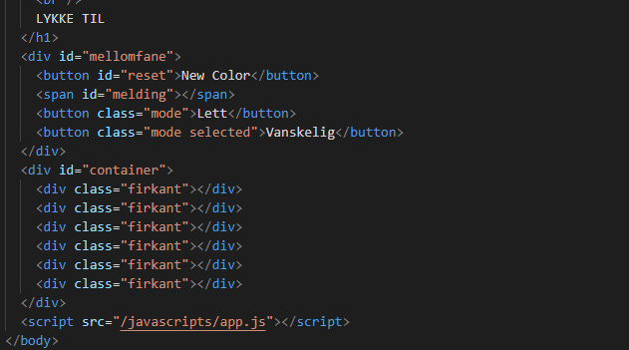*

*Overview*

This is a case study of the Colorgame app we made in our class. Our task and what to do was layed out in the GitHub repo we got. I and a classmate did this task together.

The purpose with the game is to guess the color according to the rgb code at the top. Once you click the correct color, you have won. There are two difficulties, easy with 3 choices and hard with 6.

Our solution of the task was it to be a clean and welcoming site to look at.

I am satisfied with the result. The next thing we could do is for it to be responsive.

*Context and challenge*

1. Project background and description

The Colorgame is a task we in our class got to sharpen our skills in JavaScript. We got divided into groups of 2. This was one of our first tests with JavaScript.

1. Problem/why

To make a JS game to sharpen our skills.

1. Projectgoal and objectives

There were a few perimeters we were to follow:

1. Easy and hardmode
2. The color-value of the header text should resemble the color behind it.
3. The user should restart the game without refreshing the page.
4. If a use clicks the wrong color, it should disappear.
5. When a user clicks the right color, all the other will change to said color.
6. When a new game is started, a new rbg-color will be presented.

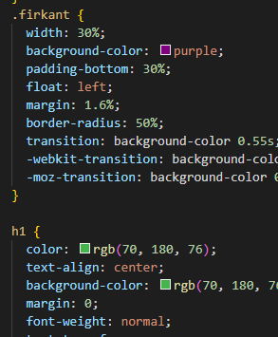*Process and insight*

We started planning of how we would do the task. It’s pretty straight forward with a small task like this. First thing on our plan-list was to research and gather inspiration. There was a point in the planning where we wanted to do a site with a crazy background that was shuffling through colors at high speed, almost like a strobe light. This we indeed tried out but it soon proved to be to much, therefore we went with the solution I describe in the next section.

*The Solution*

We went for a very clean and nice design. White background, easy readable letters and circle formed colors which were to be clicked.

*The Result*

I am very pleased with the result. A plain and simple site which is nice to see to.

